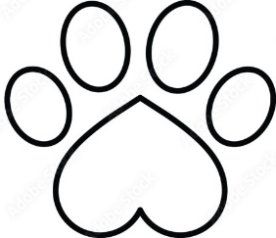


Please remember that the rabies vaccination tag is not a dog license. Dog's license can be renewed annually or every three years (If you purchased the 3-year license).
If licenses are not renewed prior to March 1st in the year following the expiration year on your previous tag, you will be charged the delinquent rate of $15 extra.

All dogs 4 months and older that reside within Clare County are required by law to always wear a Clare County dog license. A proof of current rabies vaccination is required for the license. If your dog is spayed or neutered, a copy of that record is also required for the discounted license.

Payment types accepted are cash, check, debit, or credit card + a fee for using a credit/debit card.

We Are Currently Selling 2027 & 2029 Dog Licenses.
Clare County offers 1- and 3-year dog licenses. To purchase a 3-year dog license, you need to have just received the 3-year rabies booster shot and have 3 years remaining until needed again. All licenses expire December 31st of the year purchased. Licenses can be purchased at the Treasurer's office (at the Courthouse in Harrison).
Jenny Beemer-Fritzinger
Clare County Treasurer
225 West Main Street
P.O. Box 564
Harrison, Michigan 48625
(989) 539 - 7801
Fax (989) 539 - 0866
Hours of Service
8:00 a.m. — 4:30 p.m.
Monday - Friday

