Sign Up for Emergency Alerts  Clare County uses a service (RAVE) for public wireless and internet notification. Sign up for alerts: www.smart911.com/smart911/registration  Visit www.http://do1thing.com/  Make a plan for family reunification, backup power, and special needs in case of disaster or emergency.  Make sure and think about your pets in your emergency plan.  Assemble a go-bag or kit and make sure to include a 3 day supply of water, food, and medications.  CLARE EMD  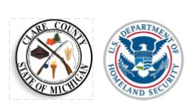 Clare County Emergency Management & Homeland Security Division 225 West Main Street Harrison, Mi. 48625 Ph.(989) 539-6161 Email: beckerj@clareco.net |  |  | Are You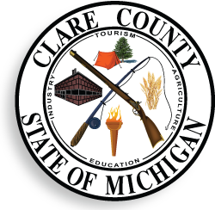 Prepared?  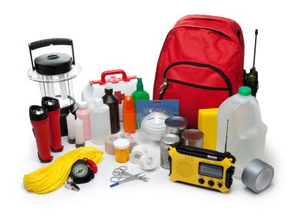  Clare County Emergency Management  - [Subtitle]

How we Communicate  - NOAA Weather Radio- local frequency 162.525/ Mt. Pleasant/ S.A.M.E. CODE 26035  - RAVE/Smart 911 Public alerting to your Computer/Cell Phone/Portable Wireless Device/www.smart911.com/smart911/registration  - Local radio and television broadcasters  - Facebook at CLARE EMD  - 211 Services/ http://www.centralmichigan211.org/  - Online at www.clareco.net_emergencyservices  - Clare County has a system of outdoor emergency alert sirens controlled by the counties dispatch system located in the following communities.  - City of Clare - Brookwood Park  - City of Clare - near the cemetery  - City of Harrison - Tank Hill area - Westlawn Street  - Freeman Township Hall  - Grant Township - City of Clare north end near Burger King  - Greenwood Township - Township Hall M-61.  - Hamilton Township Park - Dodge City  - Lake George - Silver Lake Beach  - Lincoln Township Fire Department  - Redding Township – Temple near cemetery area.  - Summerfield Township - Leota Township Hall.  - Summerfield Township – West Haskell Lake Road and Jackson Avenue  - Surrey Township Transfer Station - near Lake 13  - Garfield Township Fire Department |  |  | Who and What We Are  The purpose of the Clare County Office of Emergency Management is to protect the communities by coordinating and integrating all activities necessary to mitigate against, prepare for, respond to, and recover from threatened or actual natural disasters, acts of terrorism, or other man-made disasters. The Emergency Management Office assesses local capabilities to respond to emergency and disaster situations and advocate emergency preparedness in both the public and private sectors.  Responsibilities  - Ensure that hazards that threaten Clare County are clearly identified.  - Improve upon the local emergency response related skills of local personnel.  - Conduct exercises to test training and validate plans.  - Increase public awareness of hazards and appropriate mitigation actions.  - Identify and implement vulnerability and risk reduction measures.  - Conducts regular Local Emergency Planning Commission (LEPC) meetings.  - Assist residents and government and private sector organizations.  - IPAWS (Integrated Public Alert Warning System) Member.  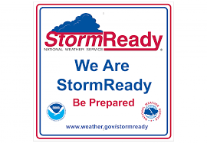  Product or Service 3  To print this booklet two-sided, click File and then click Print. Under the option that defaults to Print One Sided, select a two-sided print setting. This booklet is setup to flip on the short side of the page.

