The Clare County Office of Emergency Management
Jerry Becker/Director 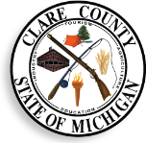
225 West Main Street
Harrison, Mi. 48625 Ph. 989-539-6161/Fax 989-539-6389
Email: beckerj@clareco.net

2024 CLARE COUNTY LEPC/LPT BOARD MEETING SCHEDULE;

Tuesday: January 16th, 2024

Tuesday: April 16th, 2024

Tuesday: July 16th, 2024

Tuesday: October 15th, 2024

Tuesday: January 21st, 2025

All meetings are held quarterly and are scheduled to begin at 9:00 A.M. unless advised in advance. All Meetings are being held at the Clare County Transit Authority Board Room at 1473 Transportation Drive Harrison, Mi.

Rev. 07/2023

