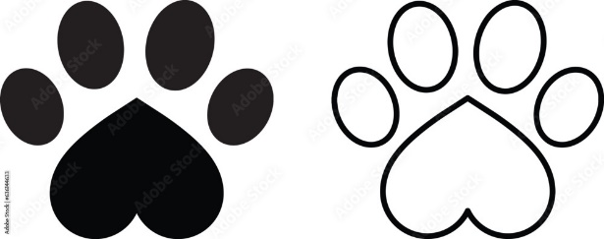

Please remember that the rabies vaccination tag is not a dog license. Dog's license can be renewed annually or every three years (If you purchased the 3-year license).

If licenses are not renewed prior to March 1st in the year following the expiration year on your previous tag, you will be charged the delinquent rate.

All dogs 4 months and older that reside within Clare County are required by law to always wear a Clare County dog license.  A proof of current rabies vaccination is required for the license. If your dog is spayed or neutered, a copy of that record is also required for the discounted license.

Payment types accepted are cash, check, debit, or credit card + a fee for using a credit/debit card.

**We Are Currently Selling 2024 & 2026 Dog Licenses.**

Clare County offers 1- and 3-year dog licenses. To purchase a 3-year dog license, you need to have just received the 3-year rabies booster shot and have 3 years remaining until needed again. All licenses expire December 31st of the year purchased.  Licenses can be purchased at the Treasurer's office (at the Courthouse in Harrison).

**Jenny Beemer-Fritzinger**

**Clare County Treasurer**

225 West Main Street

P.O. Box 564

Harrison, Michigan 48625

(989) 539 - 7801

Fax (989) 539 - 0866

Hours of Service

8:00 a.m. — 4:30 p.m.

Monday - Friday